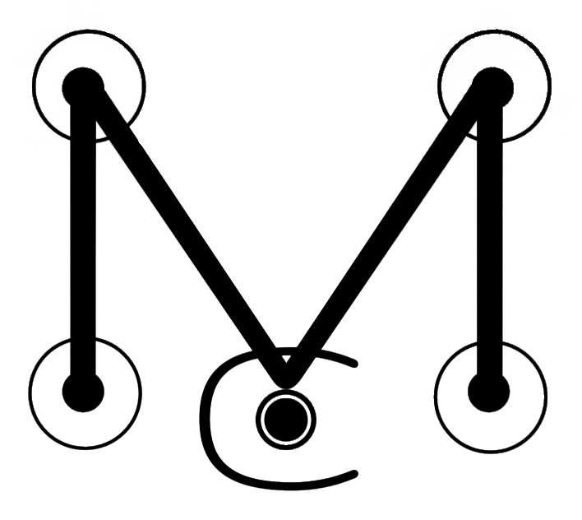

MAULKERSON CINEMATICS

ORDER OF SERVICE

Client Name(s): _________________________ _________________________

Contact Telephone: _________________________

Contact Email: _________________________________

Contact Address: ___________________________________________________

___________________________________________________

Post Code: ___________

Proposed Date of Service: ____/____/______

Proposed Location of Service: ____________________________________________

Package: Highlight / Featurette / Feature / Other

Agreed Fee: __________

Deposit Payable: __________ Paid / Unpaid

TERMS OF SERVICE

- Introduction.

This contract is formed between yourself (referred to in the Terms & Conditions as "the Customer") & Maulkerson Cinematics once the Booking Fee (min deposit of 10%) has been received. The Product or Service shall mean any product or service that is provided by Maulkerson Cinematics to the Customer. These conditions do not affect your statutory rights.

- Supply

Maulkerson Cinematics agrees to supply the product(s) or service(s) to the Customer as detailed in the Order and according to the terms and conditions of this contract.
The maximum specified turnaround time for products is 8 weeks from the date of final payment. Production will not begin until all payments have been received.

- Rights Reserved

Should Maulkerson Cinematics choose not to enforce any or all of these conditions, it should not be interpreted as a waiver of any of the Company’s rights. By providing Maulkerson Cinematics with an Order, the Customer accepts these terms and conditions.

- Payment

Maulkerson Cinematics shall issue an invoice to the Customer in respect of products or services supplied, or to be supplied. A booking confirmation deposit of 10% of the agreed fee must be paid in full to secure the service date. A further payment of 40% is required for filming no later than two weeks prior to the service date. A final settlement of 50% is required after the service date for production to begin. At each stage all payments made are non-refundable unless due to extreme circumstances as defined by Maulkerson Cinematics on a case-by-case basis (Section 13).

- Health & Safety

Maulkerson Cinematics & the Customer will act in accordance with all relevant health and safety requirements in order to provide the product(s) or service(s) under valid public liability insurance

- Creative Brief

Unless otherwise agreed, the Customer accepts Maulkerson Cinematics decisions on creativity within the product(s) or service(s).

- Liability

Maulkerson accepts no liability for any loss or damage that may arise from the supply of the product(s) or service(s). In the unlikely event of Maulkerson Cinematics being unable to supply the product(s) or service(s) as specified in the Order, liability shall be limited to the total invoice value – or monies already paid by the Customer.

- Copyright

Unless otherwise stated in the Order, Maulkerson Cinematics retains copyright in all their Original Material. Original Material includes video recordings, graphics, soundtracks, printed material and any other design or artwork commissioned by the Customer in relation to the Order. Delivery of any video content on the web is restricted to Maulkerson Cinematics only. Video conversion, web streaming and other delivery of Maulkerson Cinematics content by third parties is not permitted. The Customer must ensure that permission is sought for the inclusion of any copyright material they supply to Cinematics to enable them to deliver the product(s) or service(s). Maulkerson Cinematics retains the right to use this material in its original and edited form as they see fit, unless otherwise agreed in the Order.

- Data Protection

The Customer must ensure that all necessary arrangements have been made with, and permissions obtained from, people and places that may be recorded on video as a result of Maulkerson Cinematics supplying the product(s) or service(s) – and that such recording is in compliance with Data Protection.

- Care and Damage to client property.

Whilst every care is taken in the handling of the Customer’s property, Maulkerson Cinematics accepts no responsibility whatsoever for any loss or damage, however caused, or any other loss by unforeseen circumstances to client. Liability for such loss or damage will be limited to the replacement cost of the materials or media (the wedding film) and in no circumstances will any liability attach to any claim for the value of the content.

- Confidentiality

Unless otherwise agreed Maulkerson Cinematics will treat any information gained during the supply of the product(s) or service(s) as being private and confidential.

- Customer Material

Maulkerson Cinematics retains the right to permanently store or destroy all Customer video material upon handover of the final product(s) or service(s). Maulkerson Cinematics accepts no liability for loss or damage of product(s) or service(s) once handed over to the Customer.

- Guarantees and refunds

Due to the “one shot” nature of a wedding day, Maulkerson Cinematics makes no guarantee to film all aspects of the wedding as desired by the customer. Whilst every effort is made to ensure the quality of filming and audio coverage recorded is of the highest standard, Maulkerson Cinematics is not liable for failures in equipment that would lead to missing footage or reduced audio quality. In the event of total data loss of the entire day, Maulkerson Cinematics agrees to refund in full. Maulkerson Cinematics agrees to refund in full if Maulkerson Cinematics is unable to provide filming services on the proposed date.

By signing this document, we acknowledge that we have completely read and fully understand the above Terms of Service and agree to be bound thereby.

Full Names __________________________ _________________________

Email Address________________________________________________

Signature ____________________________ Date____________________________

Signature ____________________________ Date____________________________

Payment Breakdown

Typical Package | Deposit @10% | Filming @40% | Production @50% | Total
Highlight | £120 | £480 | £600 | £1200
Featurette | £145 | £580 | £725 | £1450
Feature | £175 | £700 | £875 | £1750

VIDEO RELEASE FORM

We, ___________________________ and ___________________________ , hereby grant permission to David Maulkerson of Maulkerson Cinematics, the rights of our image, in video or still, and of the likeness and sound of our voice as recorded on audio or video without payment or any other consideration. We understand that our image may be edited, copied, exhibited, published or distributed and waive the right to inspect or approve the finished product wherein our likeness appears. Additionally, we waive any right to royalties or other compensation arising or related to the use of our image or recording.

Photographic, audio or video recordings may be used for ANY USE which may include but is not limited to:
- Presentations;
- Courses;
- Online/Internet Videos;
- Media;
- Press;

By signing this release, we understand this permission signifies that photographic or video recordings may be electronically displayed via the Internet or in the public setting.

There is no time limit on the validity of this release nor is there any geographic limitation on where these materials may be distributed.

By signing this release, we acknowledge that we have completely read and fully understand the above release and agree to be bound thereby. We hereby release any and all claims against any person or organization utilizing this material.

Full Names __________________________ _________________________

Email Address________________________________________________

Signature ____________________________ Date____________________________

Signature ____________________________ Date____________________________

